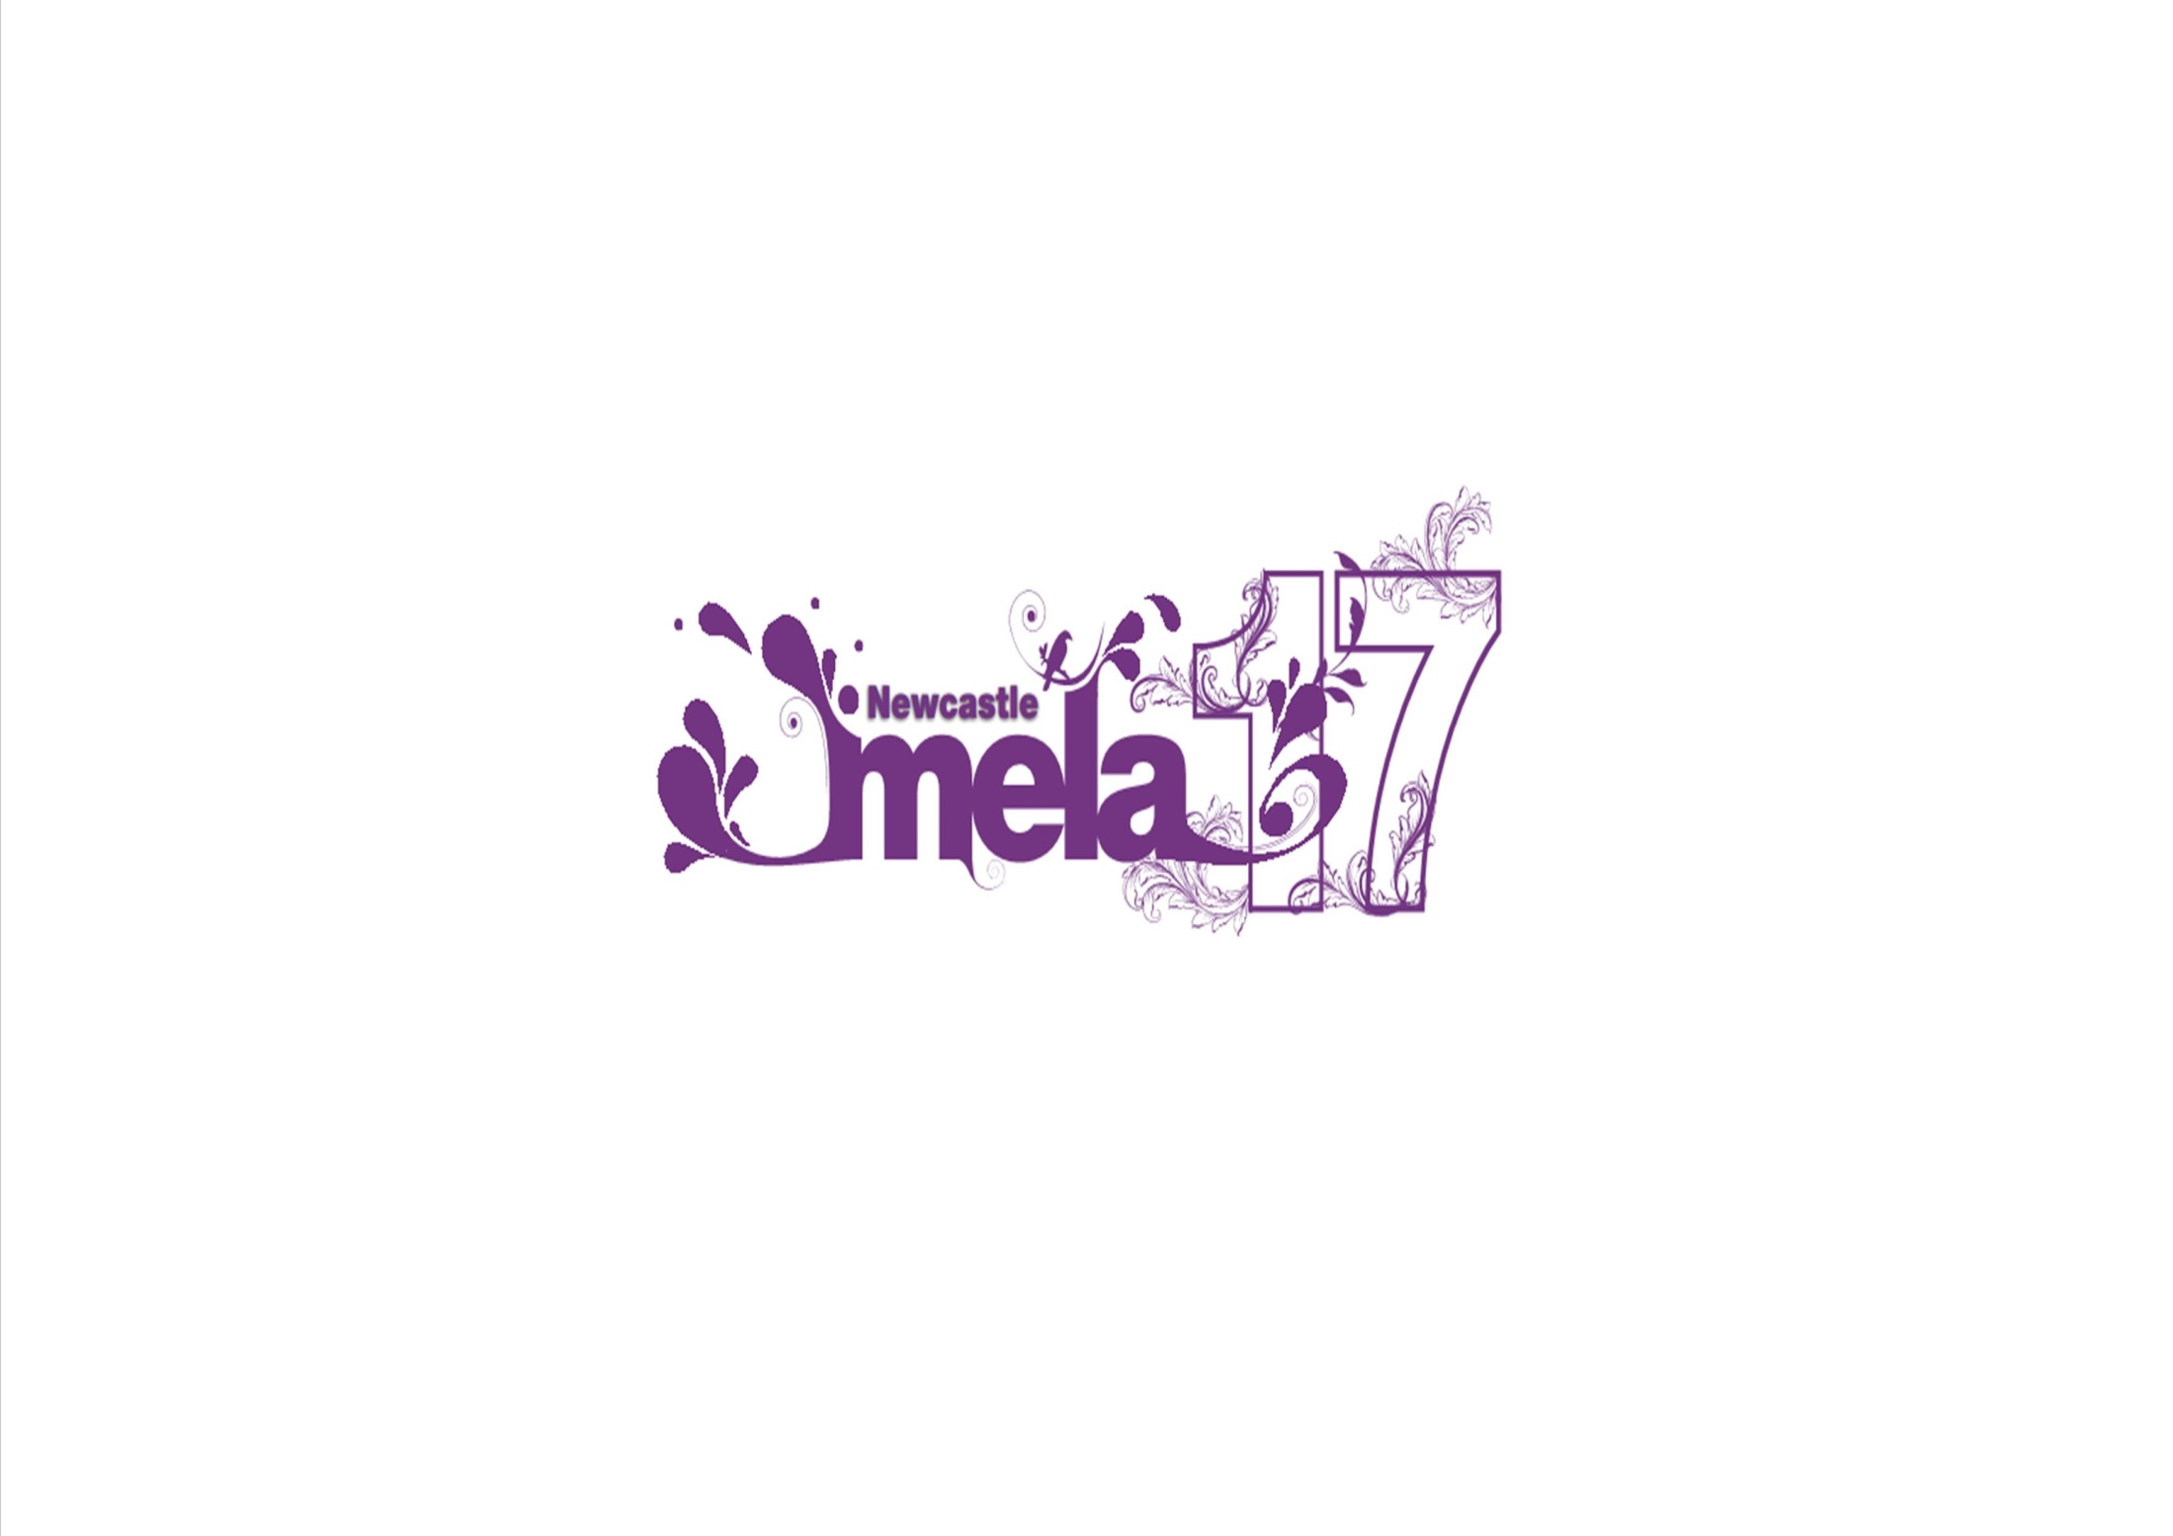

Newcastle Mela 2017
Stall booking form
Sunday 27 &
Bank Holiday Monday 28 August 2017
Exhibition Park

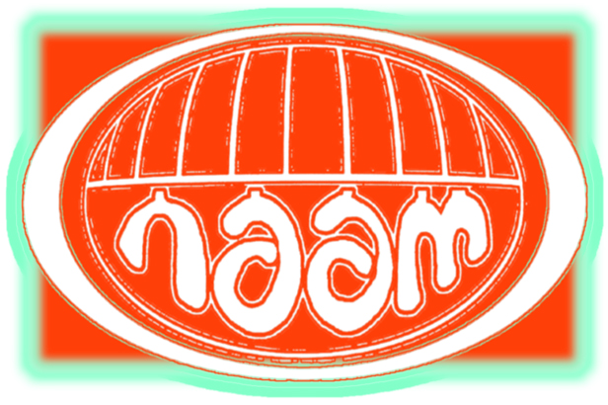

Closing Date: 8 May 2017

Checklist
Please do not send your application form until all boxes below are checked
Included a photocopy of your £5million Public Liability Insurance certificate to trade at an outdoor event
Signed the declaration on page 3
Enclosed the correct stall fee (cheques made payable to NAAM)
or
deposit stall fee direct to bank (bank details are NAAM, Barclays Bank, 20-59-42, Acc. No. 60859036, please ensure that you add your company name in the reference if doing a transfer)

Stall Deposit enclosed/sent separately

Food stall outlets only
Included a copy of your Food Hygiene Rating certificate (4 or 5 only allowed)

Details of Hirer (please print)

Mr/Mrs/Miss/Ms: ……………………… Contact Name: ………………………………………………

Business/Company Name:..……………………………………………………………………….….…….

Address : ………………………………………………………………………..……………….…….……

…………: ……………………………………………………………………..…………………….…………

Postcode :……………………………… Day time phone number..…………………………….……..

Mobile : ……………………………………………… Email: ……………….……………………………..
Vehicle Details
You may park one vehicle on site, we cannot guarantee this will be next to your stall. Other vehicles will be allowed on site for loading and unloading at the start and end of the day. There is a car park on site which you will be able to park any additional vehicles but may incur a parking charge. No vehicle movement between 11.30am and until the site is deemed safe after the event.

Vehicle Registration Number (to stay on site) _____________________________________________
Pitch Requirements – Bringing your own stall/marquee
Stall Frontage: ______ Metres

Stall Depth: ________ Metres
Maximum depth of 5m allowed for general stalls and 8m for food stalls which will include stall and vehicle parked behind (please read guidelines).

Using your own stall | Cost per metre frontage |  | Please tick which day/days attending |  | Total cost
Stall type | One Day | Two Days | Sun | Mon | Cost per pitch  (metre frontage of your stall x day/days attending cost)
Business (non trading) | £70 | £100
Catering - food | £150 | £200
General Stall  (fashion, fabric, music,  sweets, toys) | £70 | £100
Charity Stall  Registered Charity No. ____________________ | £40 | £60
Henna/ hair braiding  (*use of brown henna only) | £40 | £60
Coffee cart (per cart/vehicle) | £140 | £180
Kulfi (per trailer) | £150 | £190

MELA PROVIDED 3M X 3M MARQUEE
There are a limited a number of Mela provided stalls available and will be issued by the Mela Committee.

Using a Mela Provided 3mx3m stall | Cost per 3m x 3m Mela provided stall |  | Please tick which day/days attending |  | No. of stalls | Total cost
Stall type | One Day | Two Days | Sun | Mon | How many 3m x 3m stall do you require | Cost per stall  (stall fee [depending on day/days attending] x number required)
Business (non trading) | £300 | £400
Catering - food | N/A | N/A
General Stall  (fashion, fabric, music, sweets, toys) | £300 | £400
Charity Stall  Registered Charity No. ____________________ | £150 | £200
Henna/ hair braiding  (*use of brown henna only) | £100 | £150

Goods to be sold | Please tick | Goods to be sold | Please tick
Music |  | Books
Fabric/Clothing |  | Toys
Information (type) |  | Food
Jewellery |  | Henna*
Shoes |  | Handbags
Other – please specify

Please note we do not allow any religious or political literature to be displayed on any stall.

Newcastle Mela requires photocopies of public liability insurance for £5 million from ALL stall/pitch holders, £10 million employee liability insurance for those employing staff and Food Safety/Hygiene rating certificates from food stall holders. Failure to produce copies of these along with the application form will result in the application being refused.

Please send the correct fee for the size of pitch required and also a stall deposit fee of £100
(a separate cheque).

No refund, under any circumstances, will be given should you not be able to attend the event, please consider this before paying the stall fee.

Return Forms to: Karen McKenna,
Newcastle Asian Arts and Music
c/o 2 West Road
Newcastle upon Tyne
NE4 9HB
Phone: 07794346684 Email: Karen@newcastlemela.co.uk
Declaration
Have you read the stall guidelines booklet? Yes □ No □

Print Name ___________________________ Sign Name: ___________________________

Date ___________________________

By signing the above you are agreeing to have read and adhere to the stall guidelines and the terms and conditions of the application form.

Any stallholder failing to comply with these terms/conditions will be refused a stall and will not receive a refund.

